Manage Course Activities for Each Student

Learn how to manage and take action on course activities for individual students.

Access Student Curriculum Details

The Student Curriculum Details page gives you an in-depth view of a student’s progress in a section. You can toggle the view to Weekly Progress, a week-by-week view of a student's activities and progress.

Student Curriculum Details allows you can take several actions on an individual student’s activities: lock a course activity, unlock a course activity, hide/unhide an activity, exempt a student from an activity, unexempt a student from an activity, mark an activity as complete or as scored, reset an activity.

1. On the top bar menu, hover over **Courseware** and select your program from the drop-down. If you have only one program, simply click **Courseware** to go to your program.

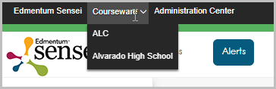

1. From My Course Sections, select a section.  
   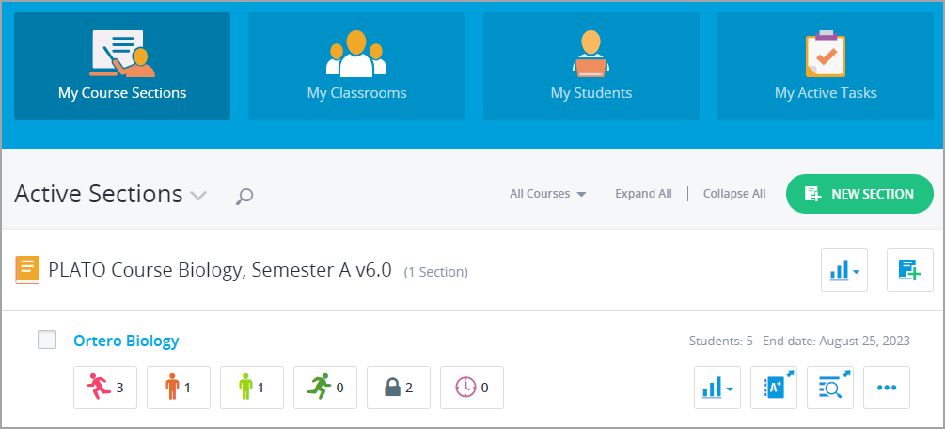
2. Select a student’s name.  
   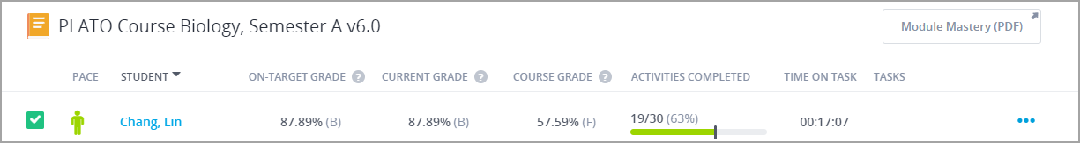

This opens the Student Curriculum Details page.  
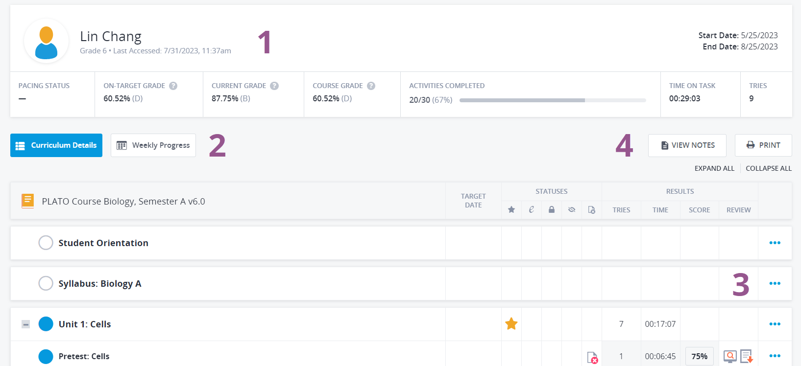

1. See details about the student, their pace, and grades.

2. Switch between the Curriculum Details view and the Weekly Progress view.

3. Select the three dots at the end of a row to view the options for that activity, including:

* Lock/Unlock
* [Hide/Unhide](https://edmentum.clickhelp.co/articles/courseware-administrator-user-guide/hide-unhide-an-activity)
* [Exempt/Unexempt](https://edmentum.clickhelp.co/articles/courseware-administrator-user-guide/exempt-unexempt-a-student-from-an-activity)
* [Edit the score for the activity](https://edmentum.clickhelp.co/articles/courseware-administrator-user-guide/mark-an-activity-as-completed-or-scored)
* [Reset](https://edmentum.clickhelp.co/articles/courseware-administrator-user-guide/reset-an-activity)
* [Omit/Include](https://edmentum.clickhelp.co/articles/courseware-administrator-user-guide/faq-omit-activities)
* [View History](https://edmentum.clickhelp.co/articles/courseware-administrator-user-guide/view-an-activity-s-history)
* [Edit Target Date](https://edmentum.clickhelp.co/articles/courseware-administrator-user-guide/edit-target-dates-for-one-student)